**GetCustomerByPhone("589.428.6764")**

**GetEquipments()**

**GetCoupon("Joy23")**

GetRentalByRentalNumber(4)

**GetRentalByPhone("589.428.6764")**

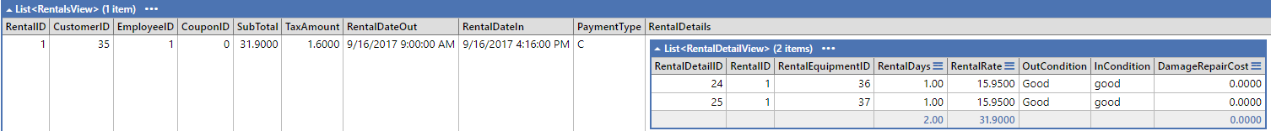

**SelectRentalByCustomer(35)**

